Submission on New Zealand’s second emissions reduction plan (2026–30): Discussion document.

Robert McLachlan

15 August 2024

0.1 What do you think is working well in New Zealand to reduce our emissions and
achieve the 2050 net zero target?

The Climate Change Response Act & the Climate Change Commission are working well.

But these are both under threat, with the government setting up a parallel review of the methane targets outside the framework of the Act, limiting its engagement with the Commission’s advice, and a minister calling publicly for the CEO of the Climate Change Commission to be removed. Climate delay and climate denial appears to be spreading in the government (e.g. our NDC has been called ‘ridiculous’ and ‘a bumper sticker and an announcement in Paris’; a minister said ‘We may have bought into the global warming narrative, but…’). Talk of expanding oil, coal, and gas production in a climate crisis, when it is well known that even proven reserves must be left in the ground for a safe future, is climate denial.

These developments have had a chilling effect on climate action and created uncertainty and mistrust.

Decarbonization of transport, industry, and electricity is working well.

But this success is due to policies in ERP1 that have since been cancelled. The impacts may be felt quickly (e.g. in EV sales) or slowly (e.g. if Fonterra revises its coal exit plan that was based on anticipation of much higher carbon prices).

Between 2019 and 2023 fossil fuel burning finally started to fall. We have turned the corner.

0.2 The Government is taking a ‘net-based approach’ that uses both emissions
reductions and removals to reduce overall emissions in the atmosphere (rather than
an approach that focuses only on reducing emissions at the source). A net-based
approach is helpful for managing emissions in a cost-effective way that helps grow
the economy and increase productivity in New Zealand.
a. What do you see as the key advantages of taking a net-based approach?
b. What do you see as the key challenges to taking a net-based approach?

The question is a little misleading as the net-based approach is written into the CCRA and no ERP has been considering gross reductions only. The question is about the balance. ERP2 proposes a significant slow-down of decarbonization, with the balance made up by forestry. It is proposed to delay the fossil fuel phase-out by 15-20+ years. I don’t think any climate scientist or climate policy expert would endorse such an approach.

The advantages of the ERP1 net-based approach are that it combines an achievable rate of decarbonization with acceptable amounts of exotic and native forestry, leaving scope to raise ambition in the future.

The challenge of the ERP2 net-based approach is that it greatly delays decarbonization (fossil fuel emissions would be 3-4 times greater in 2050 than previously envisaged), meaning that New Zealand would miss out on the advantages of the low-emission transition that is taking place globally.

A further challenge of the ERP2 net-based approach is its denial of the global consensus on climate mitigation, endorsed by our government through its membership of the UNFCCC, as expressed in the following statements from the IPCC:

The cumulative scientific evidence is unequivocal… Any further delay in concerted anticipatory global action on adaptation and mitigation will miss a brief and rapidly closing window of opportunity to secure a livable and sustainable future for all… Global targets require deep and rapid, and, in most cases, immediate greenhouse gas emissions reductions in all sectors this decade. (my emphasis)

It is universally accepted that the global effort for 1.5 ºC involves nearly complete decarbonization by 2050. In the IEA Net Zero scenario, advanced economies reach net zero by 2045, with gross emissions falling by around 90%. This is a reasonable target for New Zealand if we wish to meet the average required by advanced economies. Forestry and other removals can than take us net-negative from 2045 to 2100 as required for 1.5 ºC. Our abundant renewable energy and forestry resources make this scenario easier and more beneficial for New Zealand than for many other advanced economies.

The Climate Change Response Act requires net emissions of long-lived gases to be zero by and beyond 2050. The ‘beyond’ part is not addressed in ERP2, but it would require continued afforestation past 2050. But ERP2 is similar to the CCC’s ‘unconstrained removals’ scenario, which they reject as follows:
An approach that does not constrain carbon removals by forests would not drive meaningful decarbonisation before 2050 and would instead use up land resources for the purpose of offsetting emissions in areas where there are proven options to reduce gross emissions. This approach is not sustainable, would leave Aotearoa out of step with the rest of the world, and would leave the next generation with the task of reducing gross emissions at the same time as they will need to be adapting to escalating climate change impacts.
The ERP2 net-based approach

– does not credibly meet EB2, as there is no margin for error
– does not meet EB3 or the 2050 target
– does not meet the post-2050 target
– is high-cost, high-risk, and low-ambition.

I will explain that last point, as ERP2 repeatedly refers to the plan as ‘least-cost’. I think ‘least cost for a given level of risk and ambition’ is meant.

However, ERP2’s assessment of ‘least cost’ is based on an eccentric, minority view of climate mitigation which is not supported by any establishment assessments of the evidence such as the IEA or the IPCC. Namely, it is argued that the ETS can be the primary climate mitigation tool, only to be overridden where market barriers exist. ERP1 did partly adopt that view, but with a very different assessment of where the market barriers lie and the costs of overcoming them. The key difference is that the understanding of the need for a low-emission transition, and how it is best carried out, has been dropped in ERP2.

In 2022 David Hall and I wrote a paper ‘Why emissions pricing can’t do it alone’ that examined the evidence around this topic in detail. Matt Burgess from the NZ Initiative wrote a rebuttal that did not engage with the existing research cited in our paper; its citations led to his own earlier blog posts. Nevertheless, Burgess’s colleague Eric Crampton, also a follower of the ‘ETS only’ theory, became economics advisor to the National Party. I suspect this minority view has influenced ERP2. Basing a national climate strategy on an incorrect theory of climate mitigation will lead to failure.

In short, ERP2 is high cost because

– it is based on an incorrect theory of climate mitigation
– successful, cost-negative abatement programs have been scrapped
– numerous market barriers remain unaddressed
– it places NZ on a path to fall decades behind global climate action

Complementary policies are put in place to overcome market barriers and, amongst other things, lower the carbon prices required in other sectors. ERP2 abandons most complementary policies, but somehow manages to envisage lower, not higher, carbon prices. It is claimed that forestry will make up any amount of difference at $50/tCO2. However, this claim does not pass inspection either: the ‘Baseline’ pathway of ERP2 has forestry sequestration of 21.4 MtCO2 in 2050, exactly the same as the CCC’s ‘Reference’ pathway – which had far lower gross emissions. Something has to be wrong here. The simplest explanation is that ERP2 is not credible.

ERP2 is high risk because there are no mechanisms in place to ensure that even the weak pathway proposed will actually be followed. What if fewer trees are planted than expected, or energy emissions do not fall as expected? It will be too late to respond as trees take time to go and ETS coverage is not complete.

ERP2 is low ambition. In fact, even ERP1 was low ambition. Plans and targets are lodged with the UN in order for them to be held up to international scrutiny and ensure that we are on track to achieve the Paris Agreement’s targets. Climate Action Tracker rates our domestic policies (as of 2023) at ‘Highly Insufficient’ and consistent with a 4 ºC world. In other words, if all countries displayed similar levels of ambition, we would be on track for 4 ºC. There would be hardly any global economy left in that situation, which makes a mockery of the GDP impacts discussed in ERP2. What ‘supporting the global effort for 1.5 ºC’ means is that our policies should be such that if all countries displayed similar levels of ambition and practice, the world could meet the 1.5 ºC target.

A reasonable such pathway is that provided by the IEA Net Zero scenario for advanced economies.

Now our ambition has been lowered further with high level signals for climate delay, lower carbon prices, and much slower decarbonization. Further to the point about international scrutiny, our Long Term Plan lodged with the UNFCCC is to make ‘significant and urgent cuts in our greenhouse gas emissions and expanding our carbon sinks’. Any future revisions to the Plan are supposed to raise ambition, not lower it. Instead ERP2 is proposing to delay decarbonization by 15-20+ years.

A final challenge for the net-based approach in ERP2 is that forestry sequestration is not truly interchangeable with fossil fuel burning. Fossil carbon, once removed from underground and burnt, will stay in the biosphere, the air, and the oceans for thousands of years. Only ‘geological net zero’ will do for the long term. A new plantation forest stores carbon, but creates an equal and opposite carbon liability; the forest has to be maintained forever. Although this liability may be said to fall on the landowner, in reality it falls on all of us. Legal liability could change in the future – or the carbon liability could exceed the land value. Too much forestry in a climate plan risks delaying decarbonization, which is a cost.

I would like to see the following topics addressed in ERP2:

- The reputational and trade risks to New Zealand of lowering our climate ambition in this way.
- The impacts of planned or possible carbon border adjustments.
- How we plan to respond to the increased climate ambition required by the recent ITLOS decision.
- How we plan to respond to the Paris Agreement’s ‘ratchet’ mechanism which requires increased ambition over time; in particular, by 2035 which falls within EB3.

Chapter 2
Current modelling suggests that with a changed approach, the first emissions
reduction plan is still sufficient to meet the first emissions budget.

2.1 What, if any, other impacts or consequences of the Government’s approach to
meeting the first emissions budget should the Government be aware of?

2.2 What, if any, are the long-term impacts from the changes to the first emissions
reduction plan on meeting future emissions budgets that should be considered
through the development of the second emissions reduction plan?

The appendix lists 41 actions from ERP1 that have or are to be discontinued. Analyzing each one of them would be a mammoth task. Many actions were discontinued without any analysis being done (Ministry staff said they didn’t have time) or were effectively fait accompli, such as GPS 2024 not aligning with ERP1. Many of the changes are significant and should have been consulted on before the changes were put in place. This wholesale shredding of climate policies will have a two-fold effect on future emissions, first through their direct impact and second through the psychological signaling effect that the government does not intend to undertake a proper climate response – it’s now open slather on emissions (“it’s in the ETS!”).

Secondly, even the direct effect of some measures is hard to determine reliably. To take one example, the cancellation of the Clean Car Rebate and the level of RUC for EVs that was set. The Ministry of Transport though these would lead to EV sales falling to 24,000 in 2024; it’s now unlikely that we will even reach 12,000. The signaling effect of the CCD was perhaps even more important than the actual discount. EV prices are now as low as last year but sales are still down by 70%. On RUC, Iceland is the only other country that has imposed RUC on EVs. They too have experienced large declines in EV sales, but they are bound by EU-wide emissions targets and still have other incentives in place. We are in uncharted waters as to the effect of RUC on future EV sales.

Thirdly, the government has announced many policies that will increase emissions; these are not listed in the amended ERP1. Examples include the GPS and RoNS. Fuel efficiency standards were drastically weakened. The Ministry’s modeling of the impacts of this (which they said they hadn’t had time to do properly) is unreliable. My own estimate is that the extra emissions from vehicles sold in 2025-2027 will be 7 million tonnes CO2.

Interestingly the ERP2 modelling includes the data that the average emissions of newly registered light passenger vehicles in 2029 will be 124 gCO2/km (vs the newly enacted target of 65 gCO2/km) and for light commercials, 225 gCO2/km (new target 131 gCO2/km). ERP2 modelling is that the market share for passenger cars in 2024 will be 9% in the baseline model; it’s currently 5%. For light commercials, its 2% in ERP2 but 0.6% in actuality (Jan-July 2024). For 2030, the Baseline model has an EV market share of 22%, vs. 64% in the IEA Net Zero scenario and in the CCC Reference pathway. The conclusion is that both the modeling and the market response to government initiatives and signaling are unreliable and uncertain.

Fourthly, the CCC have advised that almost all the emissions reductions in 2022 were due to external factors like high rainfall and Covid, that may not persist. Slow economic activity from now through 2025 will further depress emissions. So, we may meet EB1 ‘by chance’, which is better than missing it, but not a basis on which to assess climate policy. We should aim to meet budgets even when external events are neutral.

Chapter 3

3.1 What else can the Government do to support NZ ETS market credibility and ensure
the NZ ETS continues to help us to meet our targets and stay within budgets?

Stop issuing consultation documents with weaker ETS settings than the CCC advice. The previous government did this too and it didn’t go well.

3.2 What are the potential risks of using the NZ ETS as a key tool to reduce emissions?

You may use false estimates of market barriers and the costs and benefits of overcoming them. Because these are uncertain, climate policy should be based on an international consensus of the evidence as undertaken by e.g. the IPCC and the IEA.

3.3 How can the Government manage these risks of using the NZ ETS as the key lever to
reduce emissions?

When considering a policy with significant climate impact, gather a broader evidence base and do not rush decisions.

Follow the advice of the CCC on price and supply settings. This is an important backstop to other policy and voluntary actions. The projected price track ($50) is far too low to ensure decarbonization outside of very limited sectors. Fonterra might even cancel its coal exit strategy at those prices. You can’t be sure the trees will materialize either as the levers are too soft.

3.4 Do you support or not support the Government’s approach of looking at other ways
to create incentives for carbon dioxide removals from forestry, in addition to using
the NZ ETS?

I support extra incentives for new large permanent native forests.

3.5 Apart from the NZ ETS, what three other main incentives could the Government use
to encourage removals through forestry?

We do not want to encourage further removals from forestry than that already considered (21.4 MtCO2/y by 2050).

3.6 Please provide any additional feedback on the Government’s thinking about how to
use the NZ ETS to reduce emissions.

Higher price corridor (eg aligned to the IEA Net Zero scenario), faster phase-out of free allocation, bring all long-lived gases into the ETS.

Chapter 4

4.1 Do current measures work well to unlock private investment in climate mitigation?

Some things have been working well. As soon as the CCRA was amended in 2019, private investment in wind farms restarted after a long period of inactivity. Solar took longer and required new market entrants. The Tiwai Point decision has unlocked a further round of investment. The CCS and CCD unlocked private investment in EVs and charging. Fonterra has strengthened their coal abatement target significantly.

4.2 What are the three main barriers to enabling more private investment in climate
mitigation?

- Climate delay and climate denial signaling from government. I am seeing nearly a full house of the ‘discourses of climate delay’, especially Individualism, Free Riding, Technological Optimism, All Talk, Fossil Fuel Solutionism, No Sticks, Appeal to Social Justice, Appeal to Wellbeing, and Change is Impossible.
- ERP2 envisaging lower carbon prices and much slower decarbonization
- No national energy policy acting as a backstop complementary measure ensuring fossilization – this was to have included a target of 50% renewable energy by 2035, but on current signals I expect this will be scrapped.



4.3 What are the three main actions the Government can do to enable more private
investment in climate mitigation for the next 18 months?

- Produce a strong energy policy in 2024 that sticks to the above renewable energy target.
- Produce a dry year strategy for the electricity sector that doesn’t rely on too much demand management or fossil fuel peaking.
- Convince the electricity generators and large energy users that decarbonization is essential and that the demand for new renewable electricity will materialize.

4.4 What are the three main things the Government can do to enable more private
investment in climate mitigation in the longer term (beyond the next 18 months)?

I am concerned by the forecasts of higher electricity prices in ERP2. Although these are not quantified, they come on the back of decades of rising prices (and record industry profits). With coordinated treatment of storage and transmission, electricity could in theory become cheaper over time under a rapid build-out of wind and solar. Rising prices could slow decarbonization and exacerbate energy poverty.

4.5 Please provide any additional feedback on the Government’s thinking about how to
enable more private investment in climate mitigation for the next 18 months.

The market signals in ERP2 are negative for private investment in climate mitigation. This negative sentiment is apparent elsewhere in government, e.g. in MBIE (EDGS did not even include a 1.5 ºC scenario). Here I compare three sets of scenarios for energy emissions: The CCC’s advice from 2021 (updated to new emission factors); MBIE’s recent Electricity Demand and Generation Scenarios report; and ERP2. The ERP2 scenarios are similar to the CCC’s ‘Current policy’ scenario – that is, to the pathway that was expected prior to the passage of the CCRA amendments. In other words, it will be as if the CCRA amendments never happened (at least by this measure).

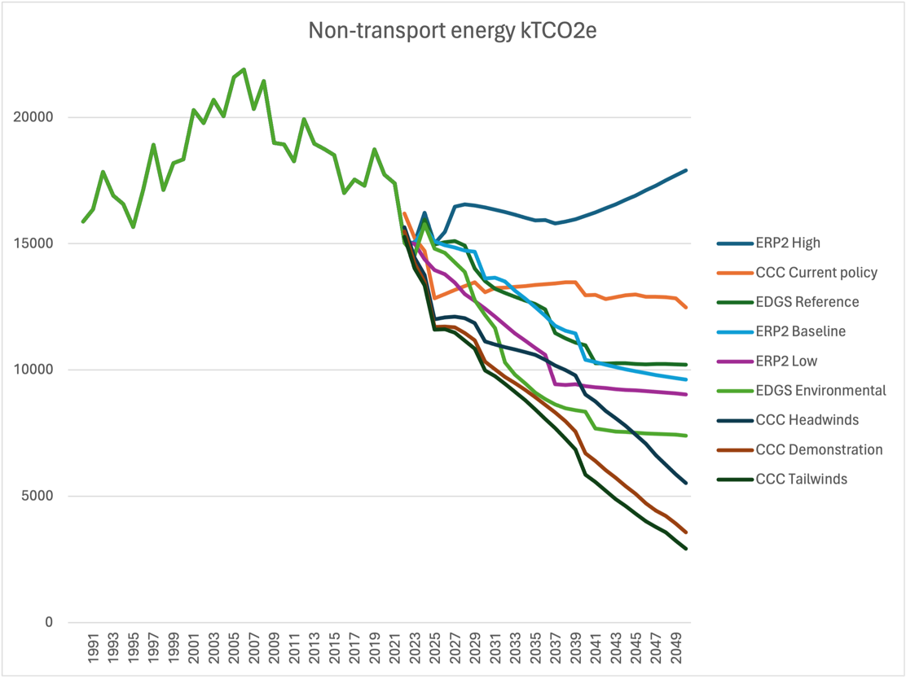
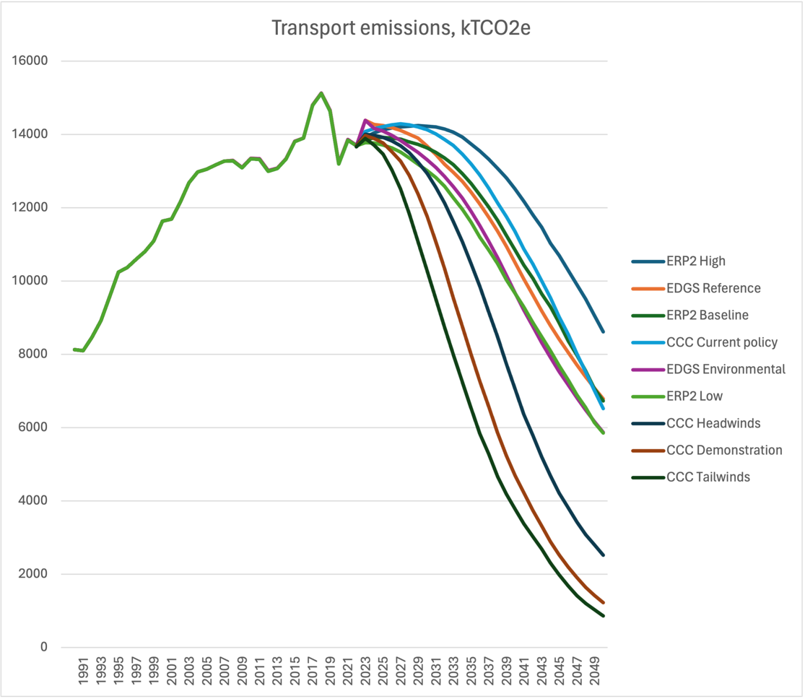

Only the CCC ‘Tailwinds’ scenario comes close to the IEA Net Zero’s requirement for a 90% reduction by 2050. ERP2 is particularly weak on transport. Transport electrification generates demand for new renewable electricity. Without a strong transport electrification policy, the wheels fall off both energy emissions and electricity policy. We cannot ‘double renewable electricity by 2050’ without strong transport and energy climate policies, as that is where the demand for new electricity comes from.

Scenario | Transport emissions, 2050, ktCO2 | Non-transport energy, 2050 | Total | Change, 2022–2050
CCC Current policy | 6514 | 12480 | 18993 | –36%
CCC Demonstration | 1226 | 3573 | 4799 | –84%
CCC Headwinds | 2519 | 5517 | 8036 | –73%
CCC Tailwinds | 857 | 2919 | 3776 | –87%
EDGS Environmental | 5867 | 7398 | 13265 | –54%
EDGS Reference | 6788 | 10215 | 17003 | –41%
ERP2 Baseline | 6729 | 9622 | 16352 | –43%
ERP2 High | 8615 | 17899 | 26513 | –8%
ERP2 Low | 5854 | 9031 | 14885 | –48%

In fact the ‘ERP2 Baseline’ scenario only increases renewable electricity 46% by 2050, a far cry from doubling. ‘EDGS Reference’ increases it by 80%.

Another example: ‘ERP2 Baseline’ includes 1.6 GW of residential solar by 2050 and 2 GW of utility solar. Australia has installed 28 GW in the past 5 years. Adjusted for population, that is like NZ installing 1 GW per year. ERP2 thinks we won’t average more than 1/8th of that rate for the next several decades. This signals extremely low ambition.

We should learn the lessons of the 2010s. For a whole decade investment in wind and geothermal energy came to a stop, because climate policy was weak and because generators did not foresee increased demand for electricity. A minister of the time even blamed the public for not using more electricity. Within weeks of the passage of the CCRA amendments in 2019, investment resumed.

Chapter 5

5.1 What three main barriers/challenges that are not addressed in this chapter do
businesses face related to investing in renewable electricity supply (generation and
network infrastructure)?

- Lack of demand. Unless there is new demand or existing power stations close, adding new supply (especially variable supply) will lower wholesale prices. Generators don’t want that.
- Electrify NZ’s focus on supply only. This puts the cart (supply) before the horse (demand). Building new renewable supply does not by itself reduce emissions. It may just add to consumption. We are seeing this already with the whole of Te Huka II’s geothermal output being sold to Microsoft for a data centre, and Kaiwera Downs Stage 2’s output being sold to Tiwai Point.
- Energy poverty means people can’t afford electricity and use less than they should for their wellbeing. Residential & industrial electricity prices used to be the same, now residential is twice industrial. Why is that?

Energy policy must balance affordability, environmental damage, reliability, equity, efficiency, and responsibility. I am not sure we are doing a good job on any of these. Do the generators really want more reliability or affordability, or do they want to keep supplies tight? Do they want more energy efficiency?

I can’t believe you actually used the phrase ‘burning more coal to keep the lights on’, a standard of climate deniers. Building more renewables will increase lake levels and lower prices. Even if we do burn more coal in the very short term, that’s a temporary effect. Meanwhile the government is meeting with the fossil fuel industry to discuss expanding fossil fuel production and consumption and is floating the idea of building an LNG import terminal, which would lock in higher emissions for decades.

5.2 How much will the Government’s approach to driving investment in renewable
energy support businesses to switch their energy use during 2026–30 (the second
emissions budget period)?

With ERP2 as it stands, when the current round of investment is over, the industry risks grinding to a halt.

5.3 What three main barriers/challenges do businesses and households face related to
electrifying or improving energy efficiency, in addition to those already covered in
the discussion document?

- Negative signaling from government
- Insufficient ambition in the residential home solar sector, which the government has been unsupportive of for years.
- Corporate action needs regulation, suitable technology, and demand. I am not seeing such a package in ERP2. Many of the technologies are known, but only become viable at higher carbon prices (e.g. c. $120/t for industrial heat). Issuing a document that talks about $50/t tells industry that these investments are not wanted or needed.

5.4 How much will existing policies support private investment in low-emissions fuels
and carbon-capture technologies?

They should continue to work for geothermal power, but not elsewhere.

The CCUS consultation document borders on techno-fantasy. For example, it talked about implementing CCUS for cement by 2030. There are a small number of such plants planned for that date globally but these are enormous projects heavily funded by governments. Likewise, CCS for gas production is only intended to increase fossil fuel use overall, which contradicts expert advice that most known reserves must be left in the ground.

Globally, CCS installations are 0.1% of global emissions. There appear to be no reliable figures on how much carbon is actually captured by these facilities – one estimate is that the capture rate is perhaps half of the installed capacity. Stories of cost overruns, delays, failures, and cancellations are widespread.

5.5 What three main additional actions could the Government do to enable businesses
to take up low-emissions fuels and carbon-capture technology?

- An alternative aviation fuel mandate aligning with the EU or UK.
- Support domestic production of alternative aviation fuel.
- Bring geological sequestration (e.g. via direct air capture) into the ETS, albeit this would require very high carbon prices to proceed.

5.6 If you are an electricity generator, please explain and/or provide evidence of how
Electrify NZ could affect projects already planned or underway.

5.7 If you are an electricity generator, please explain and/or provide evidence of how
Electrify NZ could increase the likelihood that new projects will be investigated.

5.8 Please provide any additional feedback on the Government’s proposals to reduce
emissions in the energy sector and the industrial processes and product use sector.

The other topics mentioned (hydrogen, offshore wind, alternative aviation fuels, R&D, building & construction) are all worthy of investigation but all will fail in light of the overall direction of ERP2, namely low carbon prices and low or no government investment.

The previous government’s hydrogen plans suffered from industry capture and magical thinking (e.g. ridiculous projections of 88 TWh of electricity for green hydrogen by 2050, a figure endorsed by Transpower). The final hydrogen strategy was to be released in 2024 but it’s getting quite late for it now if you intend to consult on it as I would hope. See my recent article on hydrogen for The Conversation.

Chapter 6

6.1 Do you support the proposed actions to enable EV charging infrastructure?

6.2 What are the three main actions the Government can do to reduce barriers to and
enable the development of a more extensive public EV charging infrastructure in
New Zealand (without adding too much cost for households and businesses)?

It is not credible to claim that the private sector has been lacking the confidence to invest in EV charging. The private sector has led outstandingly, assisted by government support. This is one of New Zealand’s great success stories. The fact that we were able to not only maintain but also increase the charging network relative to EV numbers during the boom of 2022-2023 is remarkable.
The discussion document states that “The future rollout of public charging infrastructure must occur at a much higher rate. At the end of 2023, New Zealand had one public EV charge point for every 88 EVs in the fleet. Most comparable countries have ratios of one charge point to fewer than 40 EVs. If the rollout lags EV uptake, this may hold back the electrification of the vehicle fleet.”
But what is a “comparable country”? NZ has way more home charging than most countries. Currently we have 1 fast (25 kW+) charger per 94 BEVs (exactly the same as the UK) with an average speed of 91 kW – pretty good. (Source: https://www.eeca.govt.nz/insights/data-tools/public-ev-charger-dashboard)
If we compare to a country with much more charging infrastructure, Germany, they have 1 fast charger per 62 BEVs, and they are faster (average 178 kW).
Charger installation has slowed dramatically in NZ from last year, just like EV sales. In Europe charger and fleet growth rates track closely together:
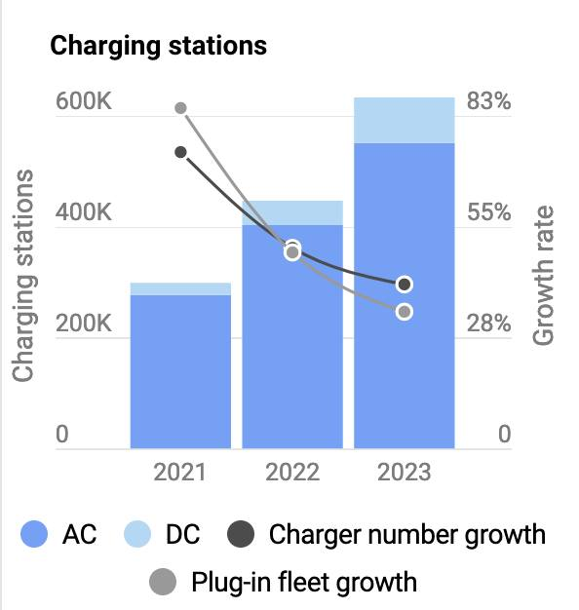
Source: https://www.transportenvironment.org/topics/cars/ev-market
Note there is a footnote that says “subject to a cost-benefit analysis” which suggests to me that the government may struggle to attract the required private co-funding now that EV sales have slowed.
To summarize:
- New Zealand has a good ratio of rapid chargers to BEVs. It should aim to maintain this ratio.
- It would be reasonable to aim to continue to increase the average speed of rapid chargers.
- We do not need as many slow chargers as other countries, due to our more extensive ability to home charge. There are exceptions in a few locations like central Wellington.
- The previous government’s policy of supporting large charging hubs on main state highways should be continued.
- The government should remove a barrier by requiring interoperability of charging networks similar to what we have for ATMs. A single fob, app, or credit card should be enough to access any public charger.
- There is a risk of private investment being strangled by the government’s ‘War on EVs’, described further below.
- Where power capacity is a limiting factor in supplying charging, the government can assist by directly funding an upgrade in capacity.
- In remote regions where private investment is uneconomic, the government can assist via a subsidy.
The Government’s ‘War on EVs’
On 16 February 2024 I published on opinion piece on the Government’s ‘War on EVs’. The four components I discussed were (i) cancellation of the Clean Car Rebate; (ii) imposition of RUCs for EVs; (iii) weakening of the Clean Car Standard; and (iv) planning to remove fuel excise duty from all light vehicles in favour of distance-only RUC. Item (i) crashed the EV market, which was no surprise. Re: (ii), we are in uncharted waters as no other country has experience with this; my estimate is its impact is similar to (i). Note that in contrast to what the Government said at the time (“RUCs were coming anyway”), action 10.2.1 of ERP1 was to look at extending the exemption. Item (iii) turned out to be far more drastic than I had realized and the Ministry were not even given time to analyse the policy’s impact in detail; my estimate is +7 MtCO2 from vehicles sold in 2025-2027. The standards are now to be reviewed again in 2026 (to be ‘achievable’); I expect the industry can end up with any standards it likes. Item (iv) amounts to a carbon tax cut of $360/tCO2, again sending us into uncharted waters.

However, since February I have come to consider that a fifth item is also important: (v) negative climate signaling from the Government.

The rebate framed EV buying as a positive thing – that is, it frames EV buying as a gain (for the environment, society etc). People are more up for taking risks when things are framed in terms of gains. Removing the rebate frames the rebate as a negative thing – as a cost (to the government, economy, taxes). Negative/cost frames discourage risk taking – so, quite apart from making EVs less affordable, removing a rebate ‘for cost reasons’ might discourage people from purchasing EVs because it will increase perceptions of risk. We now know that despite cost-cutting from retailers, EV sales have fallen far more quickly than non-EV sales.

Government policy settings establish social norms that influence the way the population things about climate friendly behaviour change. The EV rebate is a way of the government saying, we think the EVs will be good for the country/world – the benefits outweigh the costs. Most people tend to be influenced by (reasonably argued/presented) social norms – setting a new norm should increase knowledge and motivation to engage in climate-friendly behaviours.

ERP2 is laden with language about ‘cost’ – the word itself occurs 159 times. This framing, itself based around a restrictive conception of costs and benefits, encourages climate delay. In addition there have been frequent, almost daily statements of climate delay and denial from members of the Government. This sends the signal that individuals and businesses don’t have to do anything and the urgency is gone.

This effect is hard to quantify, although there is an extensive body of research in behavioural economics that supports the effects discussed above.

6.3 Do you support the Government’s proposals to reduce emissions from heavy
vehicles?

No. It is wholly inadequate. New Zealand has already made a political commitment to 30% zero-emission HDV sales by 2030, although you wouldn’t know if from ERP2.

A useful starting point is a survey of vehicle standards by the ICCT.

6.4 What are the three main actions the Government can do to make it easier to switch
to low- and zero-emissions heavy vehicles (without adding too much cost for
households and businesses)?

- Enact emissions standards like those in the EU and fulfil our commitments under the ‘Global commercial vehicle Drive To Zero’ MOU.
- Increase the rail market share of freight tonne-km to 20%. Continue to electrify rail and preserve the national rail network.
- Extend the RUC exemption for heavy vehicles to 2028 (or preferably 2030) as suggested in the modelling that accompanies ERP2. This will give confidence to private investors. The current exemption ends 31 Dec 2025 and we should aim to avoid a train-wreck like the one that accompanied the end of the light vehicle exemption.
- The $30 million grant program is a start but more is needed. For reference, in California the San Joaquin Valley has a population of 4 million people but their Air Quality Control Board has so far disbursed more than US$1 billion, mostly in 50% co-funding grants for zero-emission trucks and industrial vehicles. A similar program here would likely be cost-negative due to the damaging health impacts of diesel trucks.
- Enable an MCS charging network and co-fund charging hubs. A possible first step would be two MCS hubs co-located with the freight hubs in Palmerston North and Hamilton.

6.5 Do you support the Government proposals to reduce emissions from aviation and
shipping?

No, they are inadequate and do not respect our international commitments.

- Sustainable Aviation Aotearoa was set up to be a public-private partnership. But the public representation is very limited and does not include any independent experts, public representatives, or NGOs. Since it was established in 2022 it appears to have done nothing, not even a call for evidence or setting up a website.
- Through our founding membership of the International Aviation High Ambition Coalition in 2022, we committed to update our State Action Plan to ICAO in 2022, outlining how we planned to achieve net zero aviation by 2050. We have not done this yet.
- The statement on page 65 that domestic aviation and shipping comprise 8% of transport emissions may not be correct, as domestic shipping has switched to diesel and is no longer reported separately.
- The main routes to reducing aviation emissions are alternative aviation fuels, more efficient aircraft, and managing demand growth. Air New Zealand has been buying some alternative fuel, and more efficient aircraft, yet domestic aviation emissions are now 25% higher than pre-Covid. We need a fuel mandate matching those of the UK or EU. See my research paper for further information.

6.6 What opportunities might there be from rolling out new technologies to reduce
emissions from aviation and shipping?

- Domestic alternative aviation production could reduce emissions, enhance energy independence and resilience, and become a growth industry. However, there are some market barriers to overcome.
- Shipping has a preferred pathway forward via methanol, biomethanol, and e-methanol, which is backed by Maersk. We also have the world’s largest methanol plant. Unfortunately, Methanex is a climate laggard and has no emissions reduction target; it is not in the SBTi; it has no low-carbon or e-methanol plants under consideration or listed in the IEA hydrogen database; nor is it exposed to the NZ ETS. Despite these obstacles, biomethanol and e-methanol are a clear opportunity for New Zealand.

6.7 What are the three main actions the Government can do to make it easier to reduce
emissions from aviation and maritime fuels (without adding too much cost for
households and businesses)?

- Meet with Air New Zealand to discuss their withdrawal from SBTi and help them make a new, equally strong climate target. (See their former chief sustainability advisor Jonathan Porritt’s comments at https://www.linkedin.com/posts/jonathon-porritt_air-new-zealand-a-climate-leader-no-more-activity-7229149228281802753-WZ4A)
- Stronger pro-climate messaging, including about the damage caused by frequent flying. Flying less has a negative cost, so should be preferred under a least-cost approach.

6.8 Please provide any additional feedback on the Government’s thinking about how to
reduce emissions in the transport sector.

The Government’s thinking on transport emissions is so flawed and out of line with all conventional climate policy advice that it is hard to know where to start. Their misunderstanding of the role of the forestry and of ETS is perhaps one place to start, as these undermine the entirety of ERP2. (The consultation document on speed limits actually said that drivers ‘offset’ their emissions from driving via the ETS, which is not true. Surrendering an ETS unit may give permission to emit, but responsibility for ensuring that emissions reduce lies elsewhere.)

Following the ‘ERP2 Baseline’ pathway instead of the ‘CCC Reference’ pathway would be disastrous for New Zealand. By delaying decarbonization for decades it would expose us to high and volatile fuel prices (impacting on foreign exchange), and billions of dollars in health impacts via the NOx and PM2.5 emissions of fossil fueled vehicles. A proper cost-benefit analysis would reveal this.

Chapter 7

Please explain
- What new actions are proposed – the ones mentioned already exist
- What mechanism will ensure that farmers adopt emissions-reduction technology
- What the back-up plan is if the new technology is late or underperforming

Final comments
Both ERP1 and ERP2 adopt the language of overcoming ‘market barriers’ that prevent emissions pricing operating successfully by itself. In their advice on ERP1, the CCC provided in Table 11.1 a list of ten such barriers: imperfect of asymmetric information; uncertainty about future emissions prices; split incentives; bounded rationality and myopia; barriers to accessing capital; infrastructure lock-in; network externalities; policy coordination; co-benefits; and innovation and learning spillovers. Interestingly, transport was the only sector that was affected by all ten market barriers, and in ERP1 policies were adopted to overcome them.
While some of these policies have been ruled out, I would still like to see ERP2 engage with these barriers and to overcome them.
ERP2 is high-cost, high-risk, and low ambition. Following this path of climate delay risks missing not only the carbon budgets but missing all the opportunities and savings associated with a low-emission economy. The trade and reputational damage to New Zealand of following the path outlined in ERP2 are scarcely considered.
As well as missing the budgets, the 2050 target, and the post-2050 target, ERP2 is low-ambition in two other ways:
- It uses the existing budgets and makes no comment at all on the revised budgets as advised by the CCC. To not engage at all on this issue sends an anti-climate signal (and some of the changes were technical, not material.)
- It does not engage with our obligation under the NDC. Overachieving domestically lowers the cost of meeting the NDC. The previous government agreed to explore a hybrid strategy that went in this direction. This was achievable, and tools are already in place – for example, via the 50% renewable energy target.

A further weakness is that ERP2 does not respond to the advice of the CCC. It appears to ignore it in its entirety. It is stated that the response will be made along with the final ERP2. But under the CCRA the Government must consider the advice of the CCC in preparing its ERP and this has clearly not taken place. (Other than perhaps to consider it and reject it? If so, please explain how you are countering their comprehensive evidence.) This approach sets up an adversarial, destructive relationship with the CCC and threatens its role and independence. The CCC’s advice is based on science and international best practice and evidence. Ministers threatening to fire the CCC’s chief executive doesn’t help, either.

ERP2 can be rescued by adding least-cost policies that return the energy and transport sectors to the ‘CCC Reference’ pathway, combined with what is already in ERP2. This would meet the emissions targets and lower the cost and risk from what is currently proposed.

I acknowledge that this will be challenging, given that some best-practice, cost-negative policies have been ruled out. Even under these constraints, my top suggestions are the following.

- A solar power industry plan that aims to match Australia’s per-capita installation rate. This may involve specific measures to support the development a home-solar industry that matches Australia’s world-beating low prices, attracting new private investment.
- Where transmission and connection are constraints, direct government support of Transpower. This would prevent the electricity price rises for households and businesses described in ERP2.
- Successful delivery of the Rail Plan, including 20% market share for rail freight.
- Longer-term vehicle emissions standards that aim to catch up with Europe by the early 2030s for both heavy and light vehicles. Announce an end to ICE sales by e.g. 2035 for light vehicles and 2040 for heavy vehicles.
- Proper accounting for the costs of policies. Examples include the health costs of NOx and PM2.5 emissions, the health costs of failing to increase active transport, the increasing driving induced by motorway construction, the supply chain and price risks of higher oil consumption, the trade risks of higher emissions, and the emissions associated with urban sprawl.
- Pro-climate rather than anti-climate messaging from the Government.
- Adopting the advice of the CCC on ETS settings. This is an important backstop if other policies or voluntary efforts fail. The impact of higher carbon prices on households may be much less than anticipated – as the Clean Car Discount showed, the public and industry can respond faster than expected to the right signals.
- A stronger focus on energy efficiency, e.g. in buildings.

Hall and McLachlan, Policy Quarterly – Volume 18, Issue 1 – February 2022. A longer version, that delves into the waterbed effect in more detail, is available at https://blog.planetaryecology.org/wp-content/uploads/2021/11/emissions-pricing-working-paper.pdf
M Burgess, 2022. Pretence of necessity: Why climate change action isn’t needed and won’t help https://www.nzinitiative.org.nz/reports-and-media/reports/pretence-of-necessity/document/751
Fankhauser, S., Smith, S. M., Allen, M., Axelsson, K., Hale, T., Hepburn, C., ... & Wetzer, T. (2022). The meaning of net zero and how to get it right. Nature Climate Change, 12(1), 15-21.
Robert McLachlan, Government drastically weakens emissions standards, 16 July 2024. https://blog.planetaryecology.org/2024/07/16/government-drastically-weakens-emissions-standards/
Lamb, W. F., Mattioli, G., Levi, S., Roberts, J. T., Capstick, S., Creutzig, F., ... & Steinberger, J. K. (2020). Discourses of climate delay. Global Sustainability, 3, e17.
I Mason and R McLachlan, 2024. Hope or hype? NZ needs to be realistic about the clean energy potential of green hydrogen. The Conversation, 2 August 2024. https://theconversation.com/hope-or-hype-nz-needs-to-be-realistic-about-the-clean-energy-potential-of-green-hydrogen-234137
https://www.thepost.co.nz/nz-news/350179050/casualties-governments-declaration-war-evs
https://blog.planetaryecology.org/2024/07/16/government-drastically-weakens-emissions-standards/
Coad, A., De Haan, P., & Woersdorfer, J. S. (2009). Consumer support for environmental policies: An application to purchases of green cars. Ecological Economics, 68(7), 2078-2086. https://doi.org/10.1016/j.ecolecon.2009.01.015 Kinzig, A. P., Ehrlich, P. R., Alston, L. J., Arrow, K., Barrett, S., Buchman, T. G., Daily, G. C., Levin, B., Levin, S., Oppenheimer, M., Ostrom, E., & Saari, D. (2013). Social norms and global environmental challenges: The complex interaction of behaviors, values, and policy. BioScience, 63(3), 164–175. https://doi.org/10.1525/bio.2013.63.3.5 Osberghaus, D. (2017). Prospect theory, mitigation and adaptation to climate change. Journal of Risk Research, 20(7), 909–930. https://doi.org/10.1080/13669877.2015.1121907 Whitmarsh, L., Poortinga, W., & Capstick, S. (2021). Behaviour change to address climate change. Current Opinion in Psychology, 42, 76–81. https://doi.org/10.1016/j.copsyc.2021.04.002
Global Memorandum of Understanding on Zero-Emission Medium and Heavy Vehicles. https://globaldrivetozero.org/mou-nations/
J Miller, A Sen, and J Teter, Status of vehicle standards in Europe and North America – May 2024. ICCT. http://theicct.org/wp-content/uploads/2024/06/TTDS24-Policy-Brief-WEB-A4-65008-v5.pdf
Callister, P., McLachlan, R. I., Wild, K., & Woodward, A. (2023). An aviation emissions reduction plan for Aotearoa. https://www.researchgate.net/profile/Paul-Callister/publication/376717279_An_aviation_emissions_reduction_plan_for_Aotearoa/links/6584bb3d2468df72d3c3a73a/An-aviation-emissions-reduction-plan-for-Aotearoa.pdf

